|  |
| --- |
| **LEARNING OUTCOMES (For trainers)** |

1. Improved self-awareness: Students will gain insight into how psychosocial disabilities can affect their voice, facial expressions, and communication, leading to better understanding of their own strengths and challenges.
2. Communication skills development: Students will work towards improving their voice modulation, tone, volume, and speed to enhance their ability to effectively express emotions and ideas.
3. Social skills enhancement: Students will develop strategies to interpret and respond appropriately to facial expressions and social cues, fostering better communication and social interactions with peers and teachers.
4. Coping mechanisms and emotional regulation: Students will learn coping strategies to manage anxiety, stress, and emotional fluctuations that may impact their voice and expression.
5. Self-advocacy and empowerment: Students will develop the confidence and skills to communicate their needs and seek necessary support and accommodations to ensure a positive and inclusive learning environment.
6. Adaptability and flexibility: Students will work on adapting their communication style to different situations and interlocutors, understanding the nuances of various contexts.
7. Effective communication in stressful situations: Students will practice maintaining coherence and clarity in their message, even when faced with nervousness, anxiety, or insecurity.
8. Recognition and expression of emotions: Students will work on recognizing and expressing a wider range of emotions through vocal inflection, facial expressions, and body language.
9. Resilience and growth mind-set: Students will cultivate resilience in dealing with challenges related to their psychosocial disabilities, embracing a growth mind-set to view setbacks as opportunities for learning and improvement.

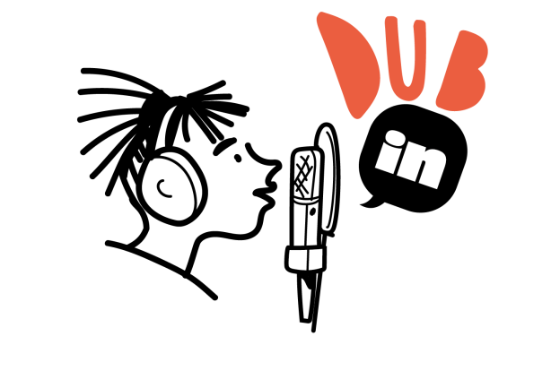

|  |
| --- |
| **LEARNING OUTCOMES (For students)** |

1. Get to Know Yourself: Learn how your feelings and emotions can affect your voice and expressions. Understand your strengths and challenges better.
2. Speak with Confidence: Practice using your voice in different ways – like adjusting the tone, volume, and speed – to express your feelings and ideas more effectively.
3. Connect with Others: Discover how to understand and respond to people's facial expressions and social cues, so you can communicate better with friends and teachers.
4. Handle Your Emotions: Learn helpful strategies to manage stress, anxiety, and emotions, so they don't affect your voice and expression too much.
5. Speak Up for Yourself: Gain the courage and skills to share your needs and ask for support when you need it. Be part of a positive and welcoming learning environment.
6. Be Flexible in Communication: Practice adjusting how you communicate depending on who you're talking to and the situation you're in.
7. Stay Clear and Calm: Learn techniques to keep your message coherent and clear, even when you feel nervous or unsure.
8. Express Yourself Fully: Explore different ways to show emotions through your voice, facial expressions, and body language.
9. Be Strong and Positive: Build resilience to face challenges related to your psychosocial disabilities. See setbacks as chances to grow and improve.

