|  |
| --- |
| **ACTING QUALITIES REQUIRED FOR DUBBING** |

1. Vocal Skill: Voice actresses/actors should be able to change tone, pitch, and sound to match the original actor's voice and show the same feelings as the original performance.
2. Emotional Availability: Voice actresses/actors should understand and connect with the character's feelings and reasons.
3. Adaptability: Voice actresses/actors need to match their performance with the on-screen actions and emotions of the original actor. They should speak at the same speed and rhythm as the character.
4. Technique: Voice actresses/actors need to make sure their voice matches the character's mouth movements when they speak.
5. Artistic Match: Voice actresses/actors can also add their own artistic touch to the character. This makes the performance unique and expressive. It also makes the character come alive.
6. Training and Experien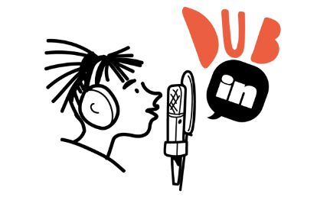ce